Requirement Analysis Phase

1. Introduction
The Requirement Analysis Phase focuses on understanding the requirements needed to restrict access to ServiceNow records based on specific field values. The system should identify the required field, verify the user's authorization, and allow or deny access according to the defined conditions.

2. Objectives
- To identify the access-control requirements.
- To identify the field used for restricting records.
- To determine authorized users and roles.
- To define conditions for allowing or denying access.
- To ensure secure access to restricted records.

3. Activities Performed
- Analyzed the requirement for record-level access control.
- Identified the required table and field.
- Identified authorized users and roles.
- Defined the field values that should be accessible.
- Determined the ACL operation such as Read or Write.
- Documented the conditions for granting and denying access.

4. Expected / Produced Output
- List of functional requirements.
- Identified table and field for access control.
- Defined authorized users and roles.
- Defined access conditions.
- Requirement specification for implementing the Script-Controlled ACL.

Screenshot

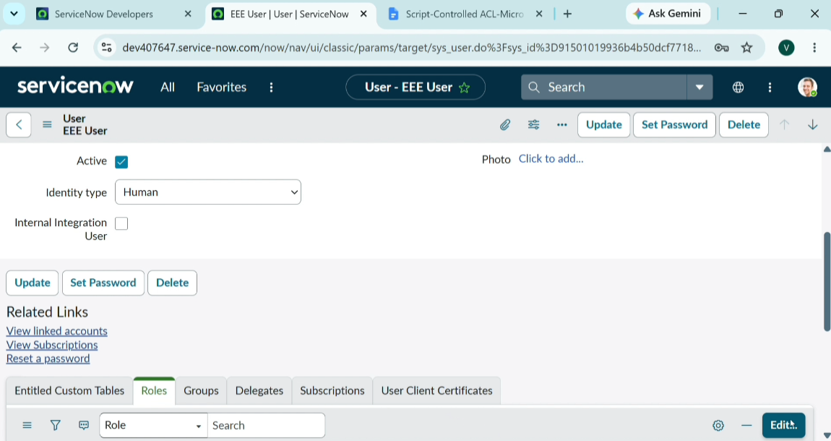

5. Data Flow Diagram (DFD)

